# 



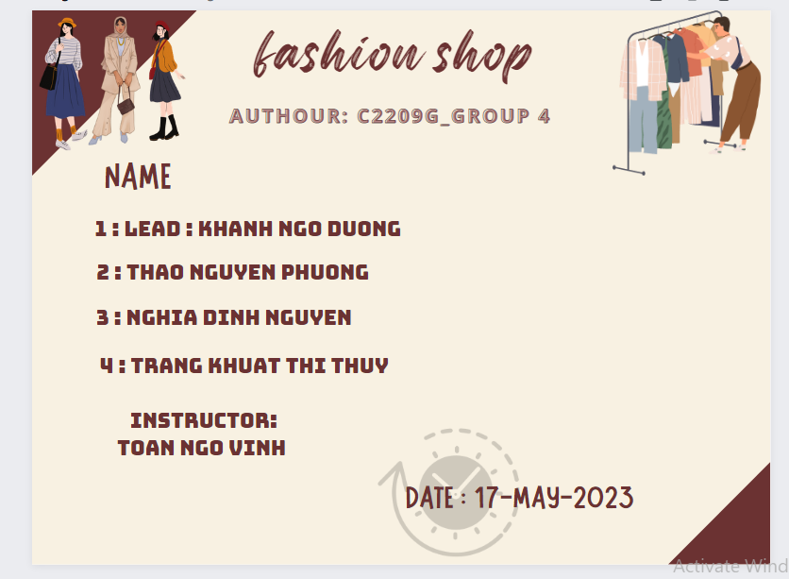

Hanoi, 17-May-2023

## Acknowledgement

Our e-Project 1 needs assistance to be done and we, the authors, would like to give our acknowledgement to those who have supported and motivated us during the period of implementing this e-Project 1.

First and foremost, we would like to thank our instructor Mr. **Ngo Vinh Toan** whose support and useful advice helped us to complete our e-Project 1 effectively. His encouragement and comments had dramatically enriched and improved our work.

Secondly, we would like to thank Aprotrain - Aptech Computer Education, teachers, and staff for their support throughout our learning and completing this e-Project 1.

Thirdly, we would like to thank our families’ members including our parents, spouses and siblings for their support and care all the time, especially in the period of completing our work.

Lastly, our deep thanks come to all our classmates during studying time in Aptech. Their kind help, care, and motivation help us conquer the higher targets in the future.

# Problem Definition

## Problem Abstraction

The consequences of the Covid-19 pandemic have forced people to implement online business methods to maintain stores. People no longer like to visit a market or shopping mall to shop, instead That's why they prefer to search or shop directly over the internet to limit going out as well as contacting people. This saves them time and also helps the online business of many businesses become more prosperous. more developed.

Understanding the needs of consumers as well as realizing that need, our team decided to jointly build a fashion sales website to create a modern sales system and contribute to promoting. for your personal brand.

* 1. ***The Current System***

Currently, the store is still doing business according to the old method, customers can only come to the place to see and buy products that cause inconvenience to customers far away. Because customers do not have the conditions to travel during office hours, during that time, the personal demand for fashion is very high. Therefore, in order to help the store increase monthly revenue and reach customers easily and give them interesting and convenient experiences, the store changed its business method from online sales to online stores. doing business with the online method combined with the old method. Not only that, the use of online business also contributes to helping businesses expand their business scale not only in one place but everywhere. Satisfying both the number of customers who want to see the goods directly and want to buy them online.

After all, the effectiveness of this new business form is very beneficial for both consumers and businesses, contributing to promoting the economy in a positive and developing direction.

## The Proposed System

The home page will have horizontal menu items made up of matching icons. Some tips can be included in the blank area of ​​the website. On the website, there will be available titles that are right and suitable for what the business has. In the menu item, there will be sections: Home page, men's item, women's item, children's item, sales service, feedback, shop location, product search. In the product section, there will be sections: Women's fashion, Men's fashion, Kid's fashion, Cosmetics, Accessory,. There is a contact page which will have the business address displayed by geolocation API , email address and business hotline. In case the user wants to contact the shop they will enter the name , email and include a message or will Contact the shop directly via the hotline.

## Boundaries of the System

The website provides information on global fashion products. For customers who want to learn and choose to buy and sell fashion items that suit their needs. Customers can use the information for reference.

## Hardware and Software Requirements

**Hardware:**

•The minimum system requirement to host the website and allow user to access all functions is a computer with an Intel Core™ i3 processor or equivalent.

• System has at least 2GB RAM, 8GB RAM is recommended.

• 1GB free of disk space, 512GB solid state drive (SSD) is recommended for the best performance.

**Software:**

• Windows Server 2012, Windows 7 or higher version.

• A server software (XAMPP, LAMPP…) with MySQL database management.

• An up-to-date browser (e.g., Google Chrome, Microsoft Edge, Safari, Firefox, and so on.)

# Customer Requirements Specification

## Users of the System

The system can be used by customers and administrators.

- Customer is a user who only accesses the main website to view and interact with information (shopping, reading product details, viewing descriptions, prices, etc.). similar). Customers can register as members to be able to order their own products.

- An administrator is a person who has system-wide rights, performing tasks such as customer information management, product information management, designer information management, collections, order management, management order details, add edit delete products, designers, collections.

***2.1.1 Customers***

◉ Get access to view and shop products based on collections, designers

◉ You can comment or contact the admin by email

◉ Member Registration

***2.1.2 Administrator***

◉ Have the right to manage products (add, edit, delete)

◉ Have the right to manage the collection (add, edit, delete)

◉ Have the right to manage the stylist (add, edit, delete)

◉ Have the right to manage orders, orders details (view)

◉ Get permission to manage contact information (view)

## System functions

2.2.1. **Homepage**

+ Description: for first time customers. The homepage is divided into sections:

- All products: Show all products of the shop

- Designer: Show all designer of the shop

- Contact us: provide head office address, phone number, contact email

2.2.2. **Products page**

+ Description: For users who want to see all recommended products. There will be illustrations, product names, prices.

+ Display: Name, price, image, short description,...

2.2.3. **Function To View details of each product type**

For customers who want to see full product information

+ Processing: Export from the database detailed information: name, image, price, designer name, collection name.

+ Display: Detailed information of each product

2.2.4. **Contact Us Function**

+ Description: For those who want to provide comments, reviews, or feedback on the problems.

2.2.5. **About Us Function**

+ Description: introduction about the company.

2.2.6. **Search Function**

+ Description: For users who want to search for product information by collection.

+ Display: products that match the search query.

2.2.7. **Cart Function**

+ Description: Customers can add the items they want to buy. The shopping cart will show the total cost of all the items and allow the customer to delete or modify the items.

+ Display: cart information including photo, name, quantity, total amount of products.

2.2.9. **Payment Function**

+ Description: Customers enter information to be able to pay for the products added to the cart

+Display: cart information including photo, name, quantity, total amount of products and form payment.

+ Handling: validate input information, if valid, add a new dimension to the database, otherwise display a warning.

2.2.7. **Login Function**

+ Description: For customers who want to buy products, contact

+ Display: login with email, password.

2.2.8 **Administrative functions**

Login function:

+ Description: For administrators to access the Administration functions. Access to all functions, products and management.

+ Input: Username and password.

+ Processing: Retrieve the database and check if the account exists or not, the password is correct or not. If the account or password is wrong, deny them login.

+ Display: Login interface including account and password.

+ Flowchart:

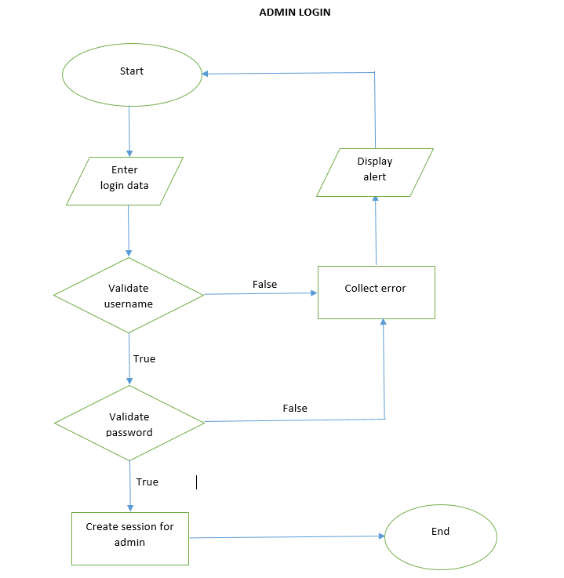

2.2.9. **Function to add new Collection:**

+ Import: Admin can add new collection.

+ Handling: validate input information such as name, if valid, add a new dimension to the database, otherwise display a warning.

+ Privileges: only administrators can access this function.

2.2.10. **Function to Edit Collection:**

+ Working operation: Click on the update button next to the collection information

+ Handling: Retrieve data from the database, retrieve old collection information and allow new collection information to be entered

+ Display: Returns a list of new collections that have been updated

2.2.11. **Function to Delete Collection:**

+ Working operation: Click on the delete button next to the collection information

+ Handling: Retrieve data from database, delete data about selected collection.

+ Display: Return new collection list after delete

2.2.9. **Function to add new Stylist:**

+ Import: Admin can add new stylist.

+ Handling: validate input information such as name, image, description, if valid, add a new dimension to the database, otherwise display a warning.

+ Privileges: only administrators can access this function.

2.2.10. **Function to Edit Stylist:**

+ Working operation: Click on the update button next to the stylist information

+ Handling: Retrieve data from the database, retrieve old stylist information and allow new stylist information to be entered

+ Display: Returns a list of new stylists that have been updated

2.2.11. **Function to Delete Stylist:**

+ Working operation: Click on the delete button next to the stylist information

+ Handling: Retrieve data from database, delete data about selected stylist.

+ Display: Return new stylist list after delete

2.2.9. **Function to add new Product:**

+ Import: Admin can add new product.

+ Handling: validate input information such as name, price, image, description, stylist, collection, if valid, add a new dimension to the database, otherwise display a warning.

+ Privileges: only administrators can access this function.

2.2.10. **Function to Edit Product:**

+ Working operation: Click on the update button next to the product information

+ Handling: Retrieve data from the database, retrieve old product information and allow new product information to be entered

+ Display: Returns a list of new products that have been updated

2.2.11. **Function to Delete Product:**

+ Working operation: Click on the delete button next to the product information

+ Handling: Retrieve data from database, delete data about selected product.

+ Display: Return new product list after delete

2.2.11. **Function to Order Management:**

+ Import: Admin can manage orders that customers have ordered

+ Handling: Click to view order to see order details

+ Display: Display information about the order such as: customer name, email, phone number, address, order date. Display detailed information about the order: order number, name, quantity, price, total amount

2.2.11. **Function to create new user account**

+Enter: Customers can create new user accounts

+ Procedure: Enter fullname, username, email, phone number and password. If the information is valid, create a new user account, otherwise: display a warning message.

# System Designs

## Database Design

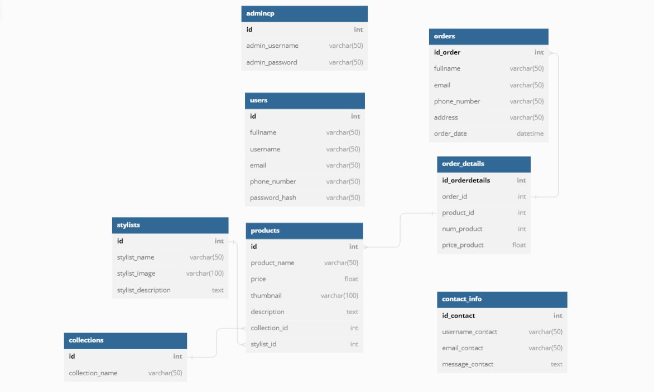

## Sitemap

## 

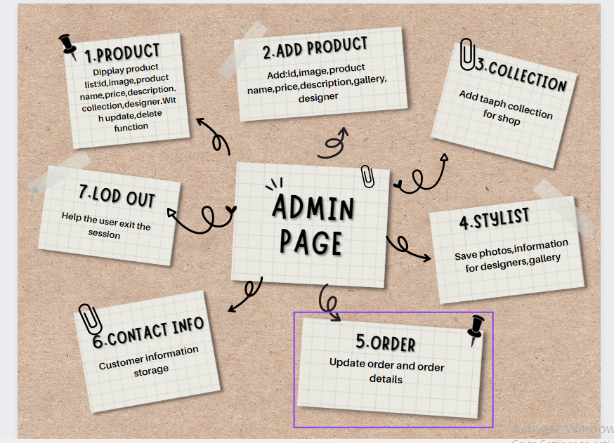

## System functions design

* + 1. Admin Interface

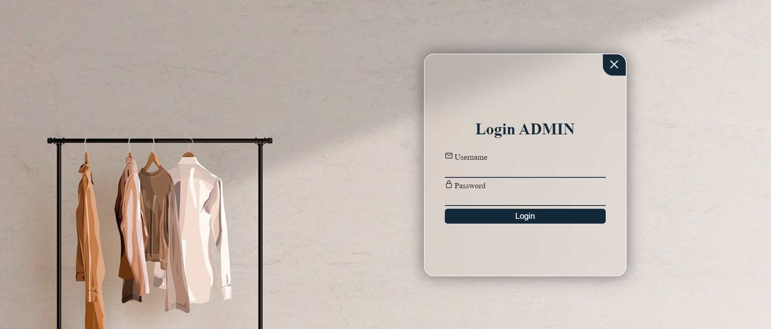

* Admin page

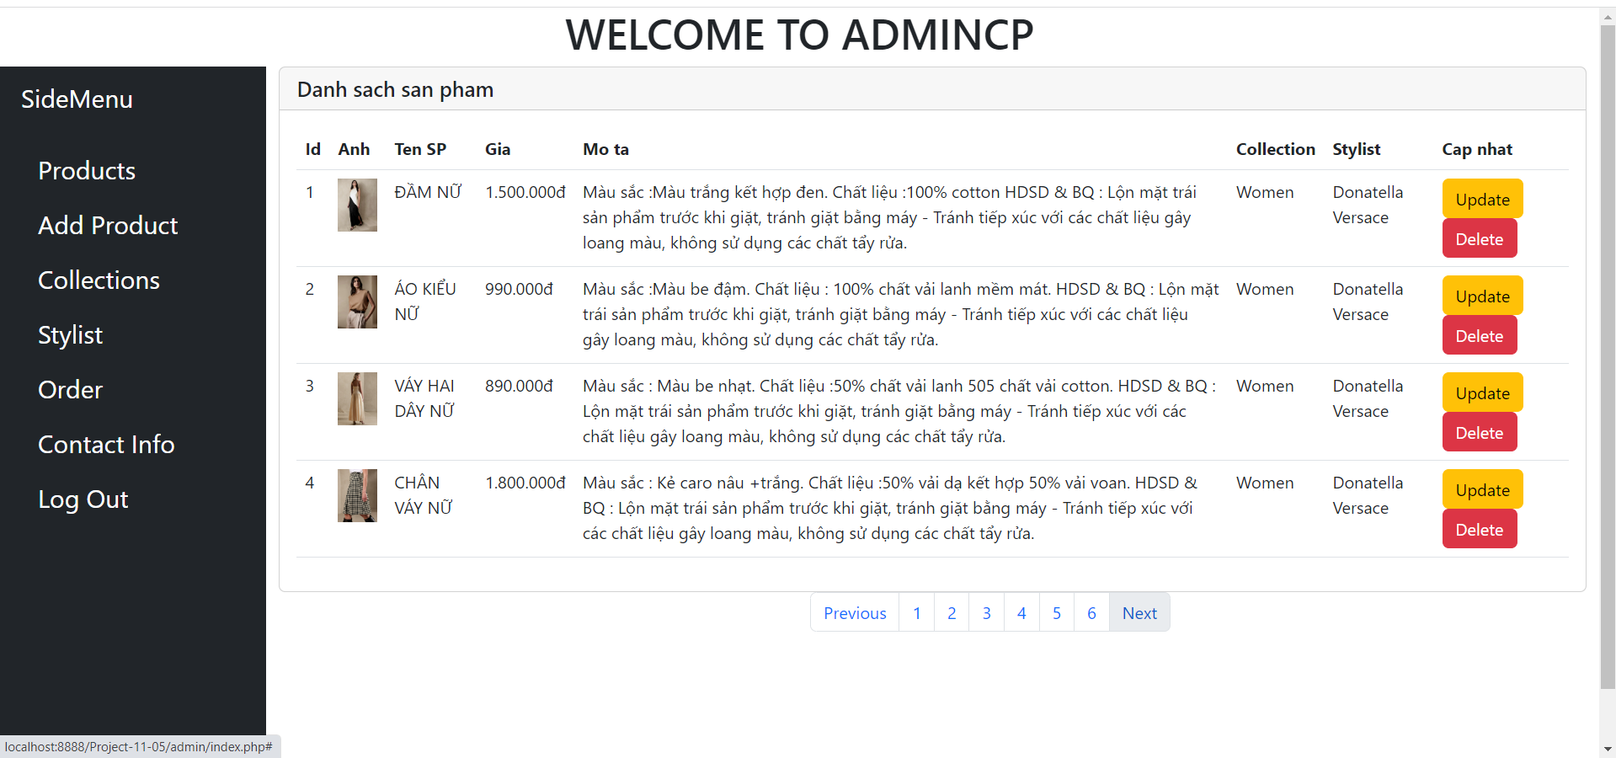

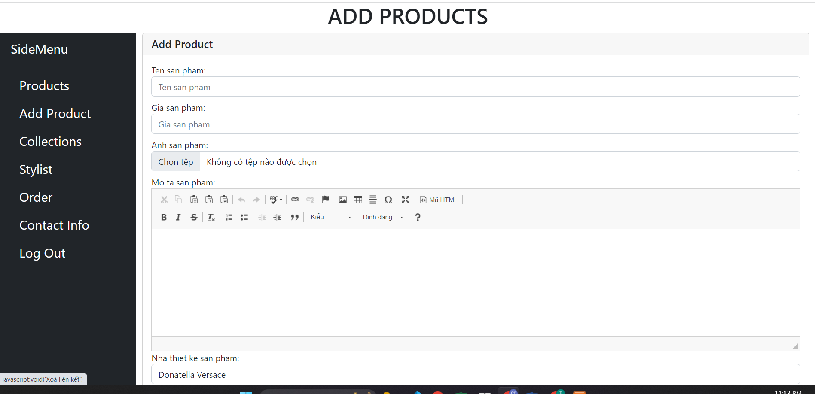 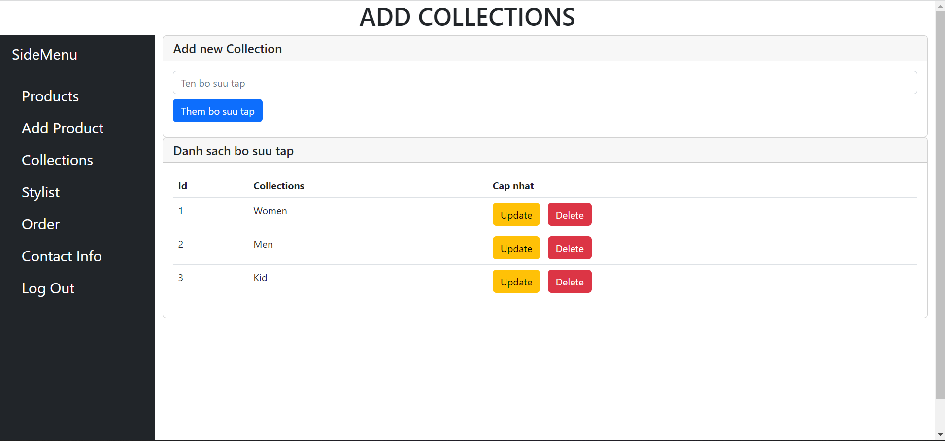 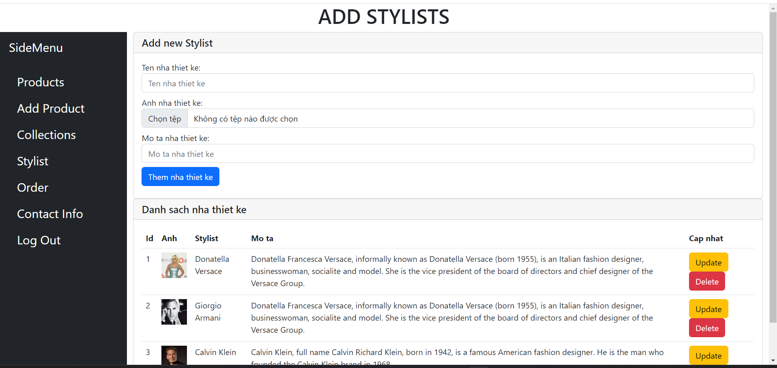 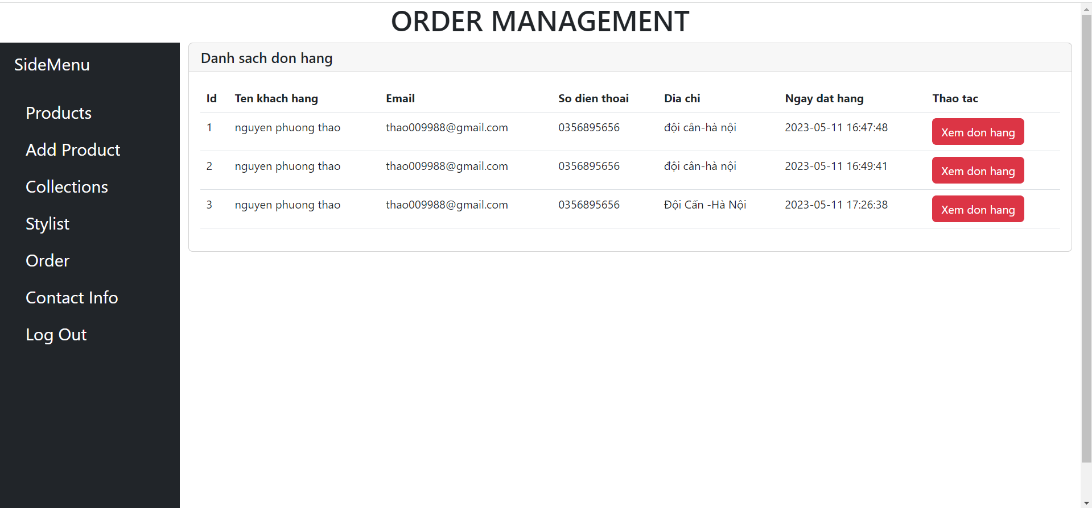 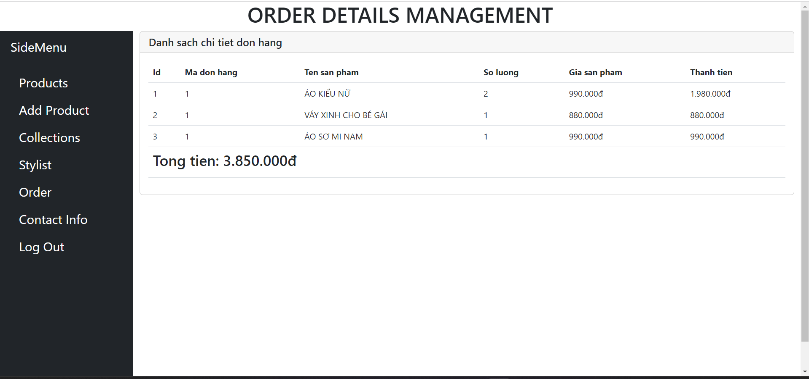 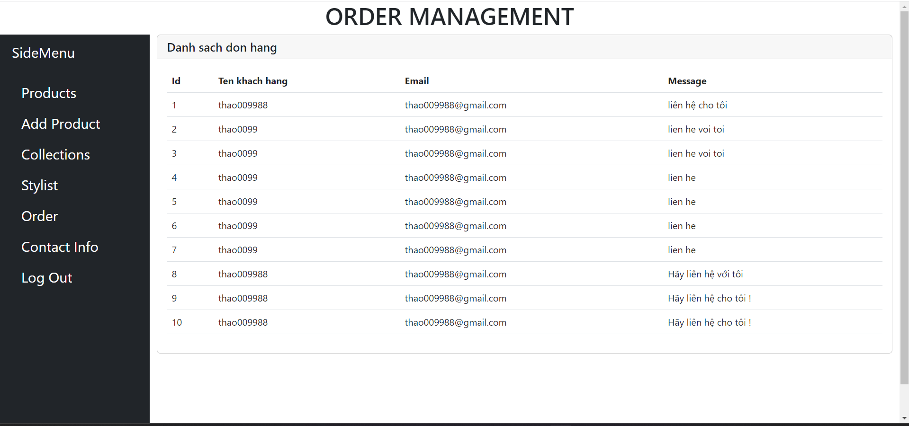

* + 1. User Interface
* Log in

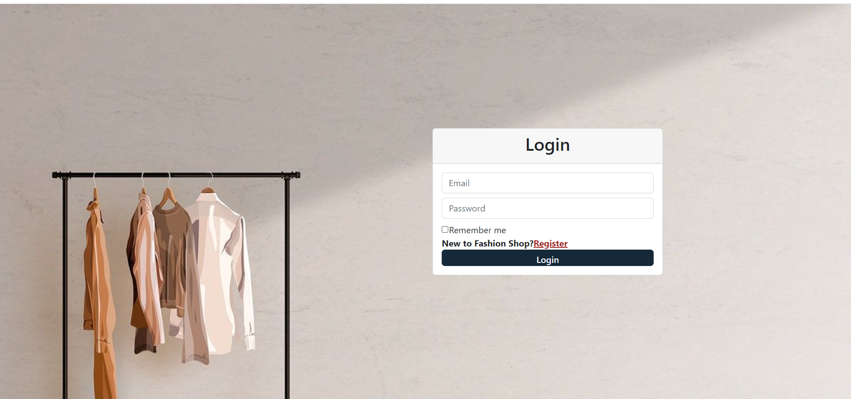

* Sign up

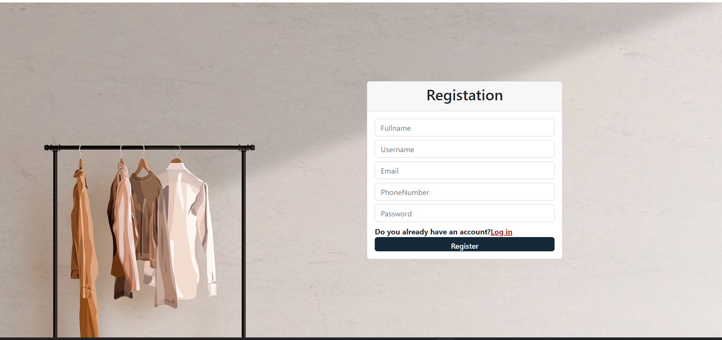

* Home page

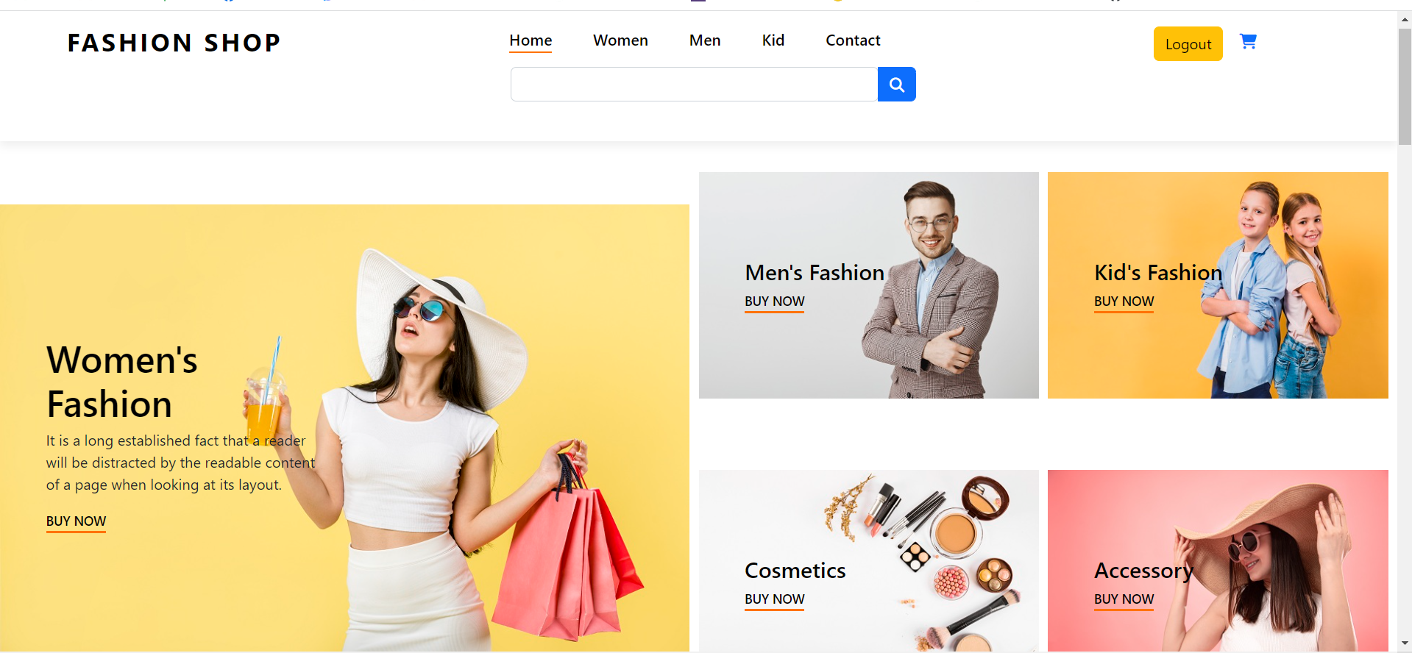

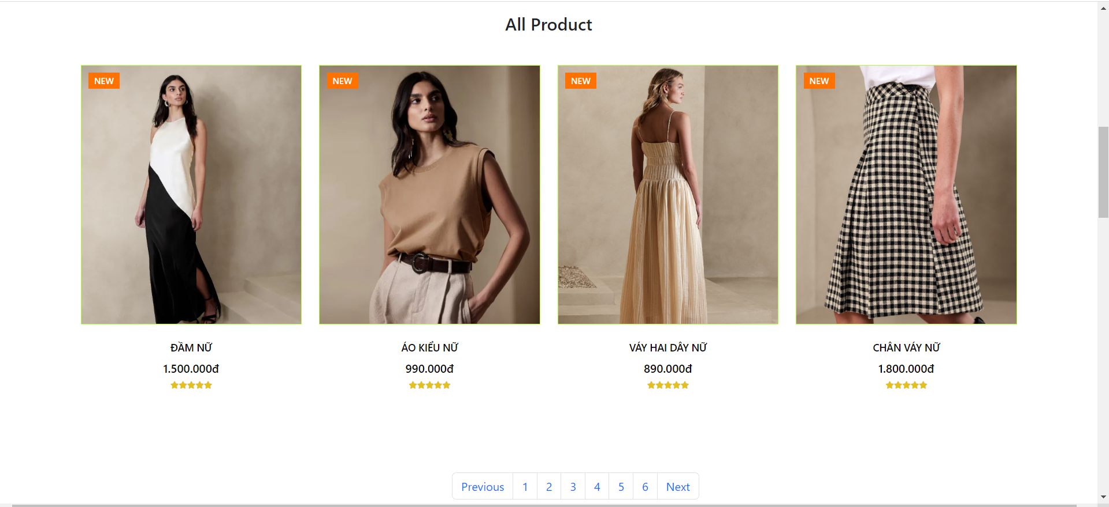 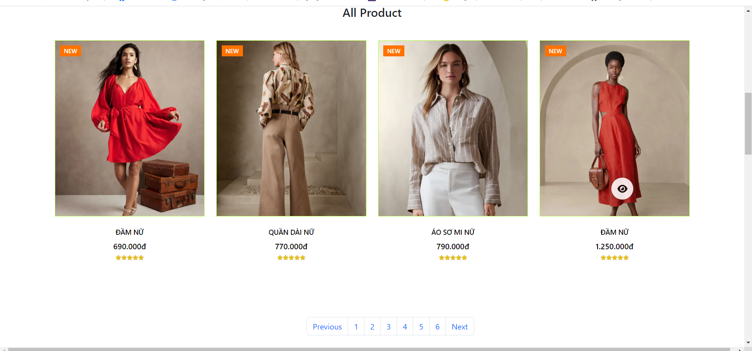 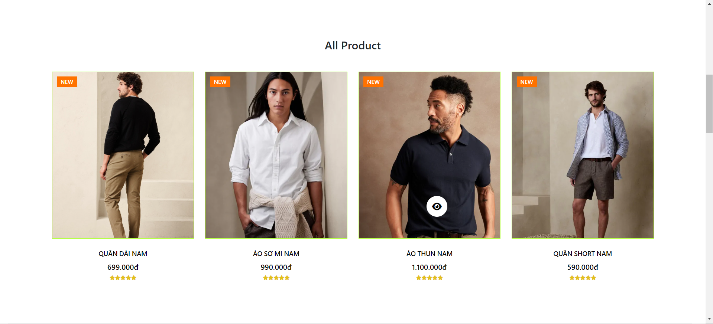 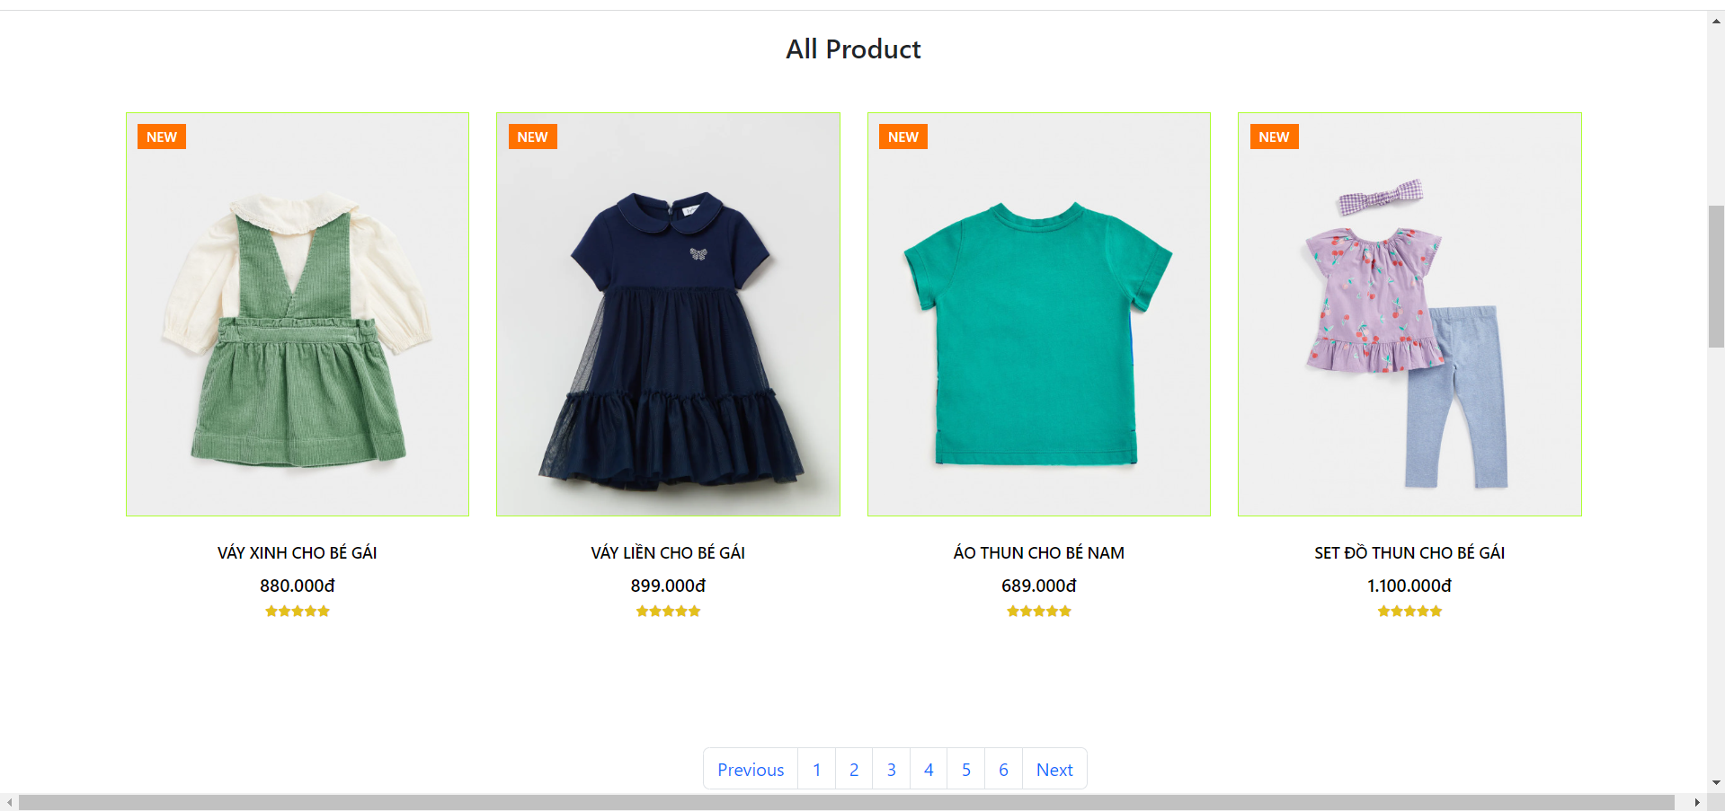 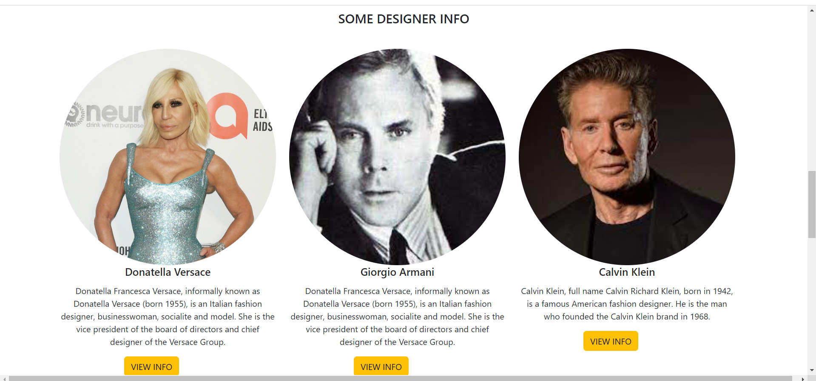

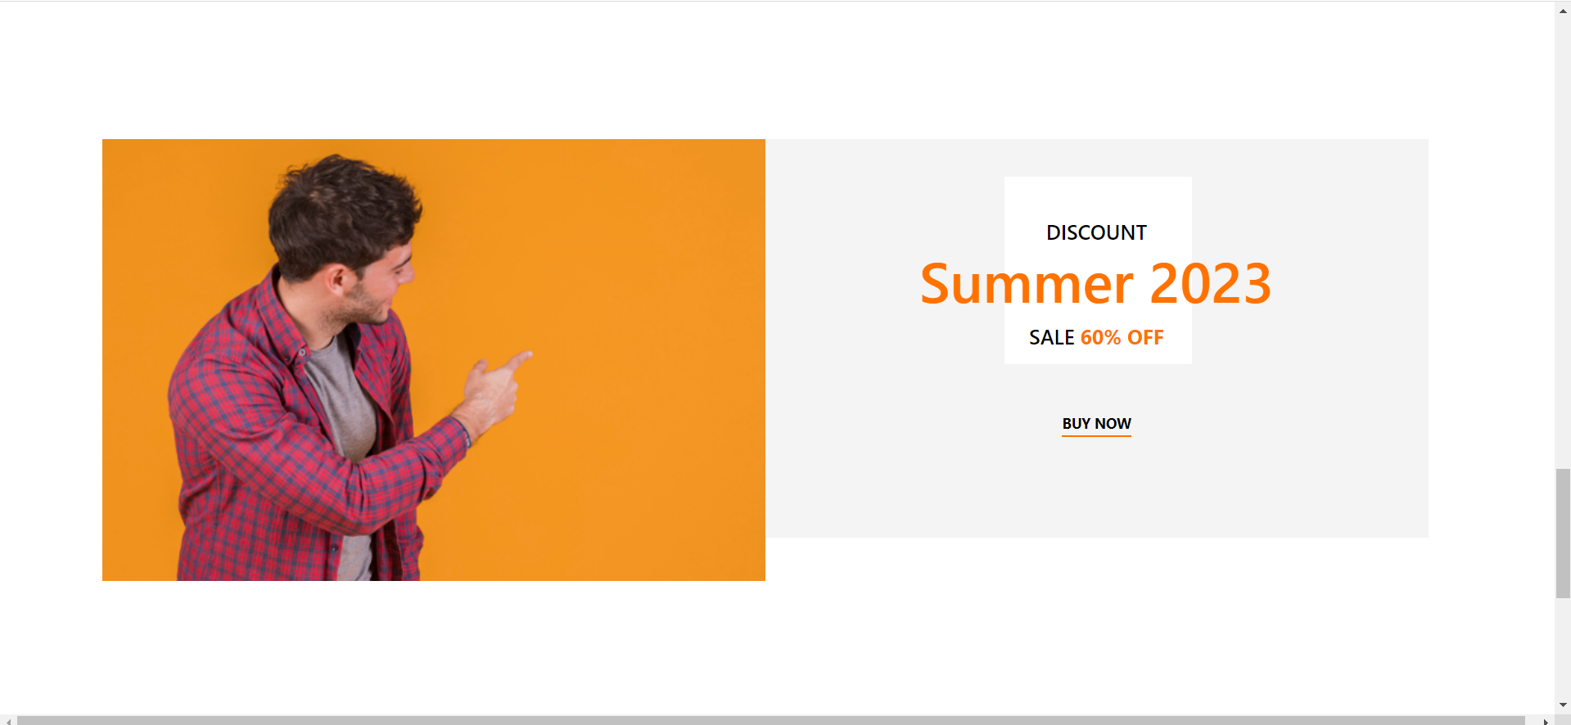

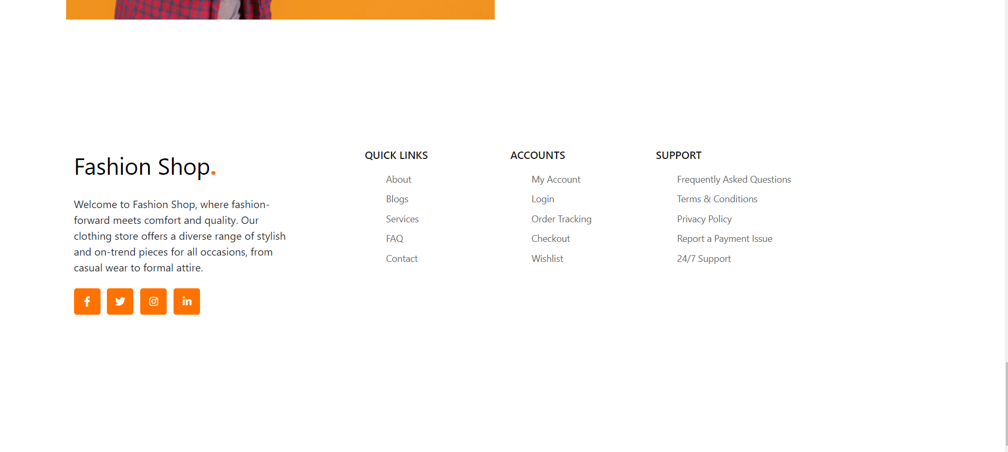

* Women.

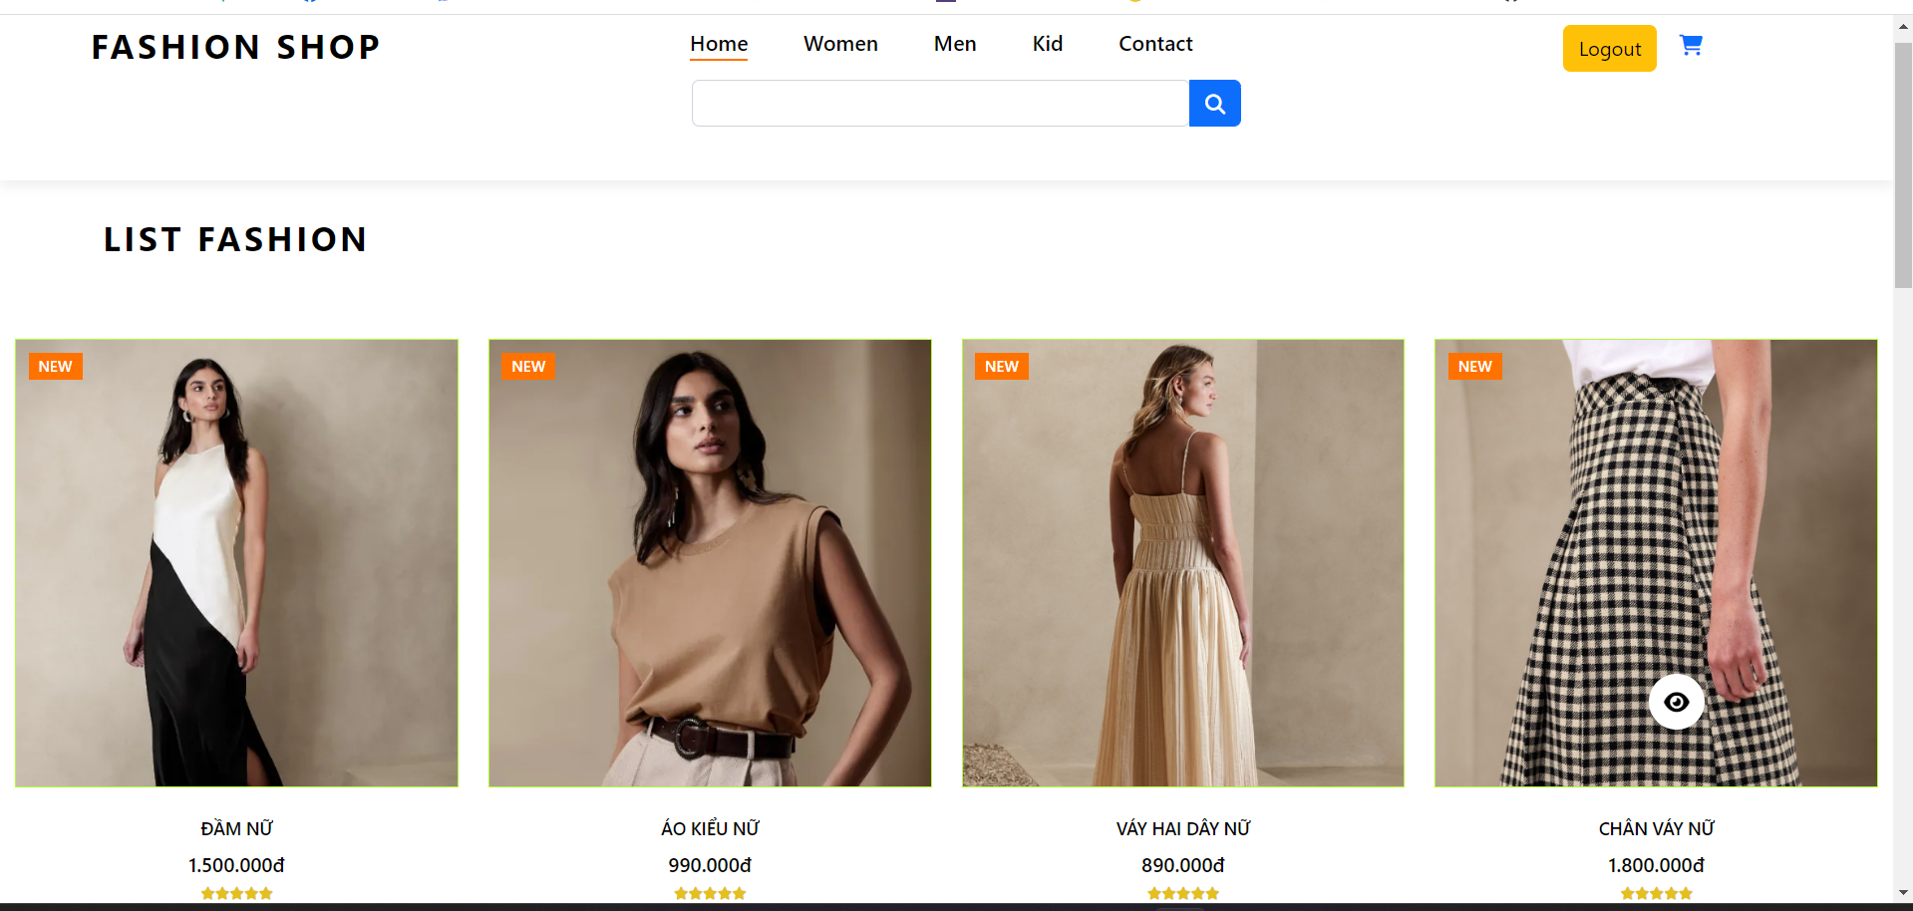

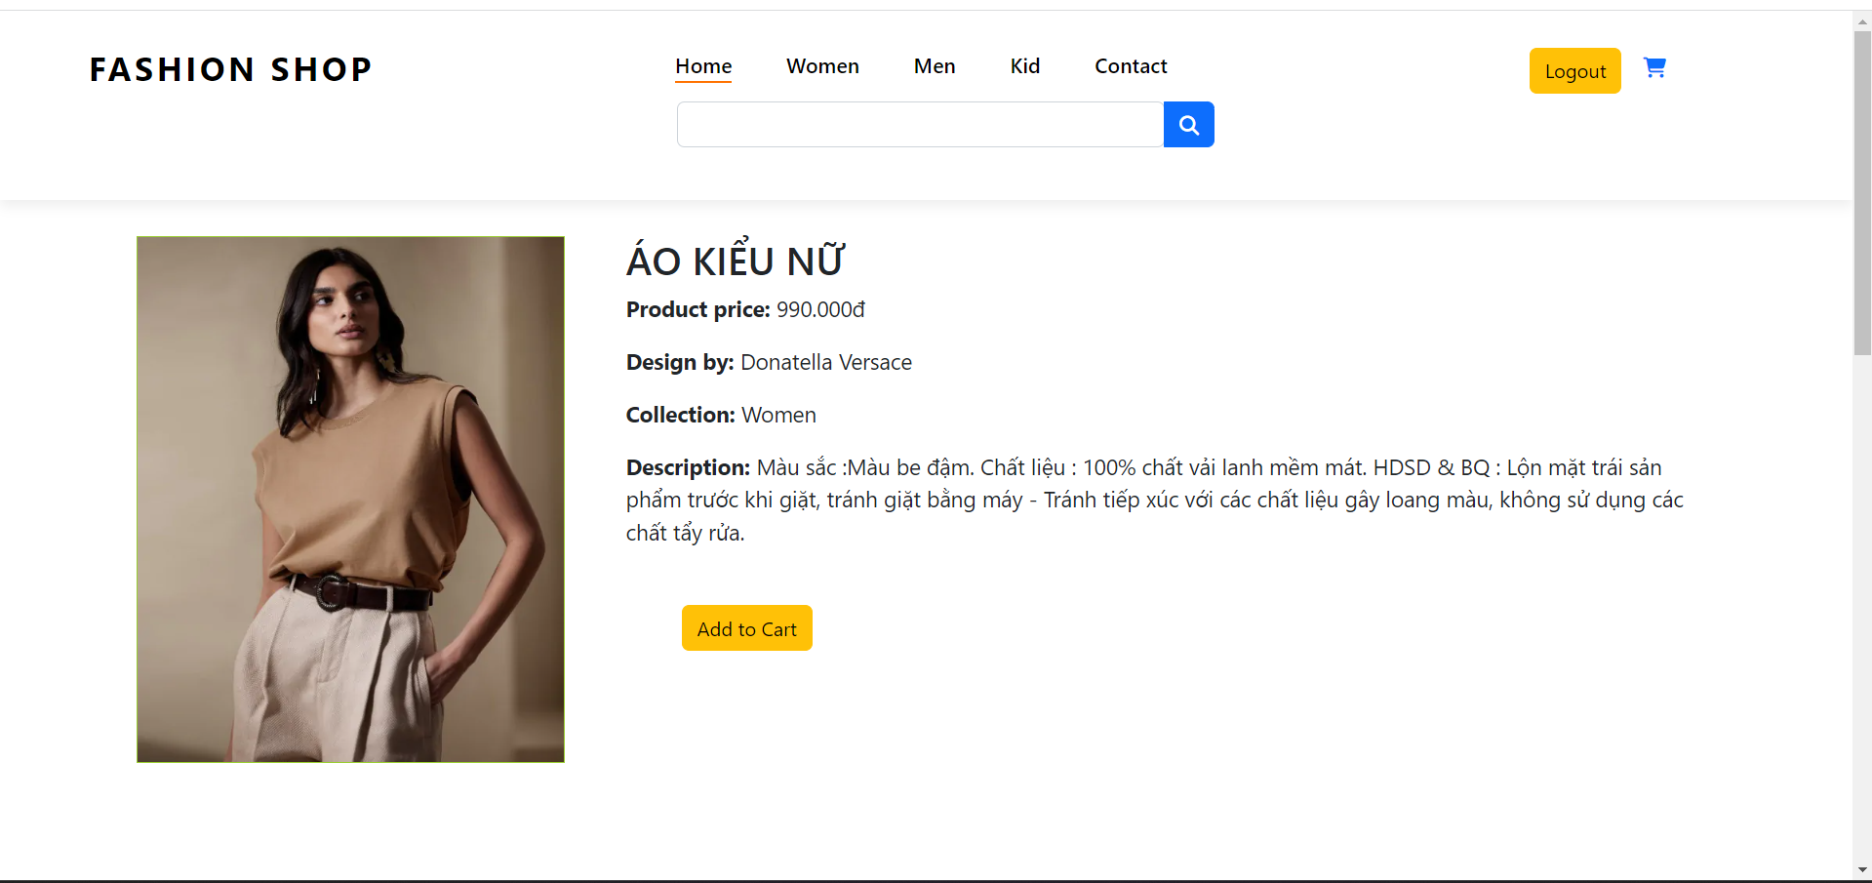 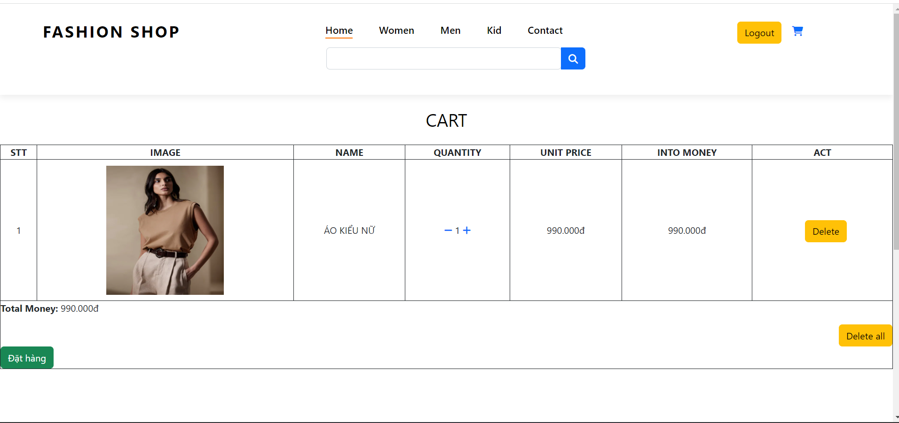

* Men.

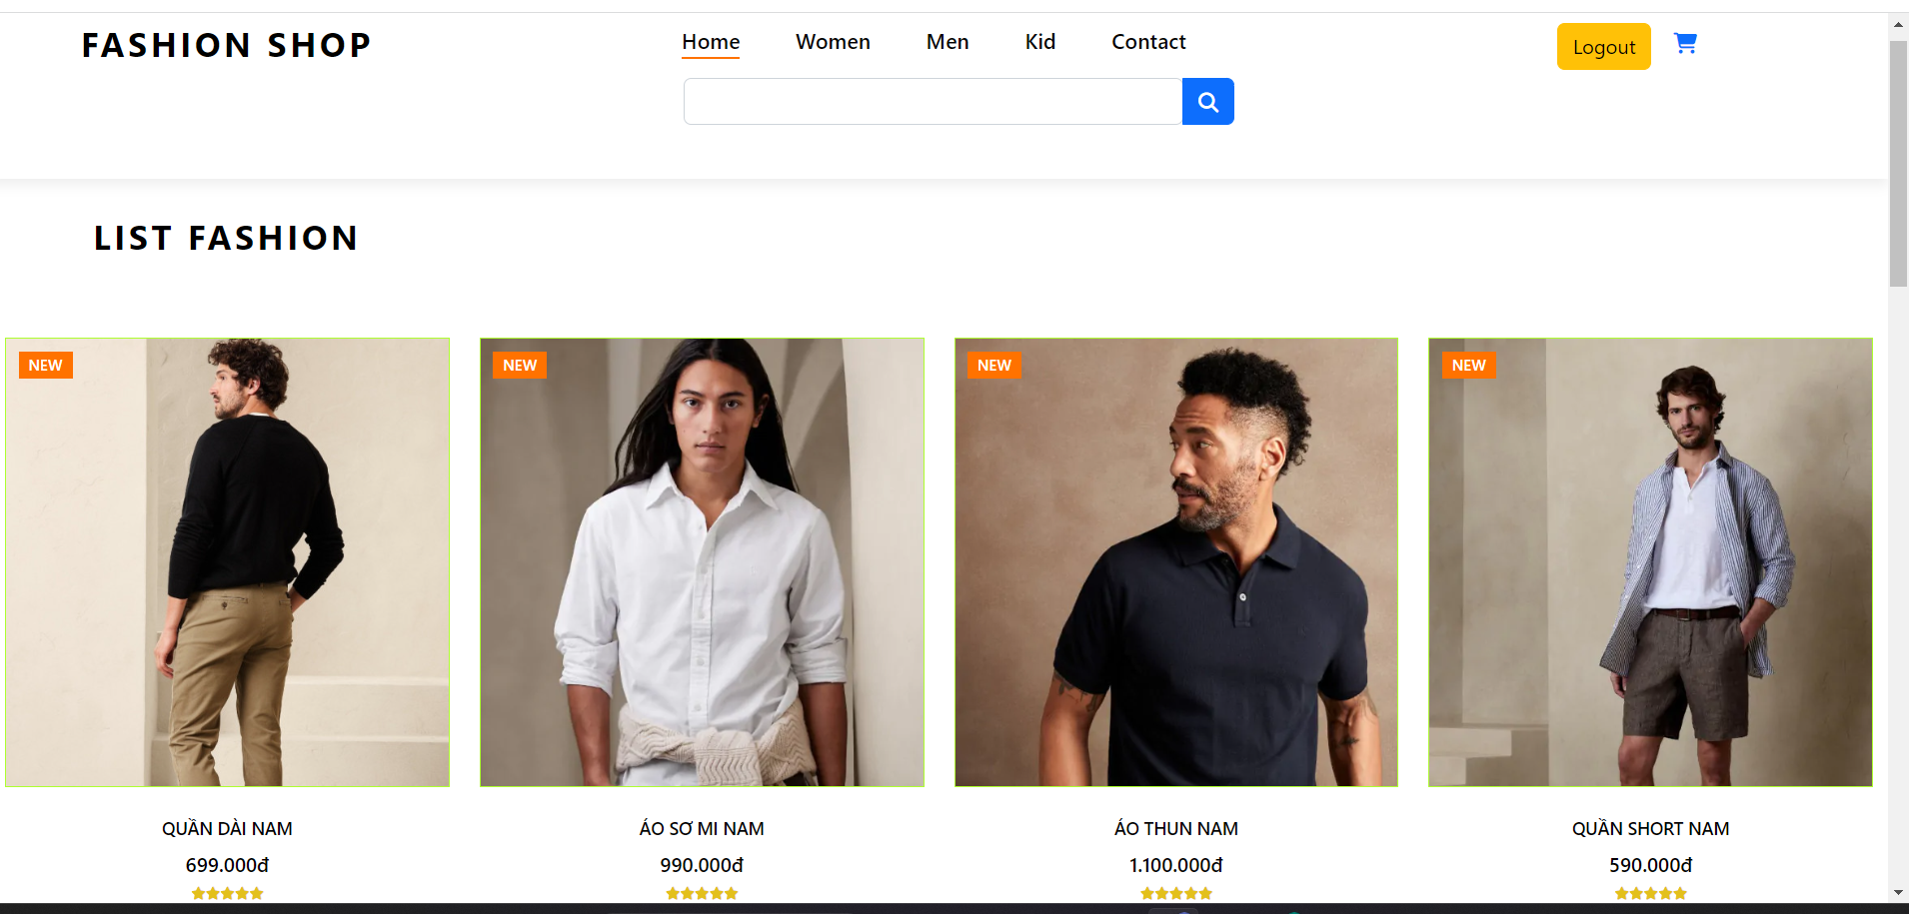

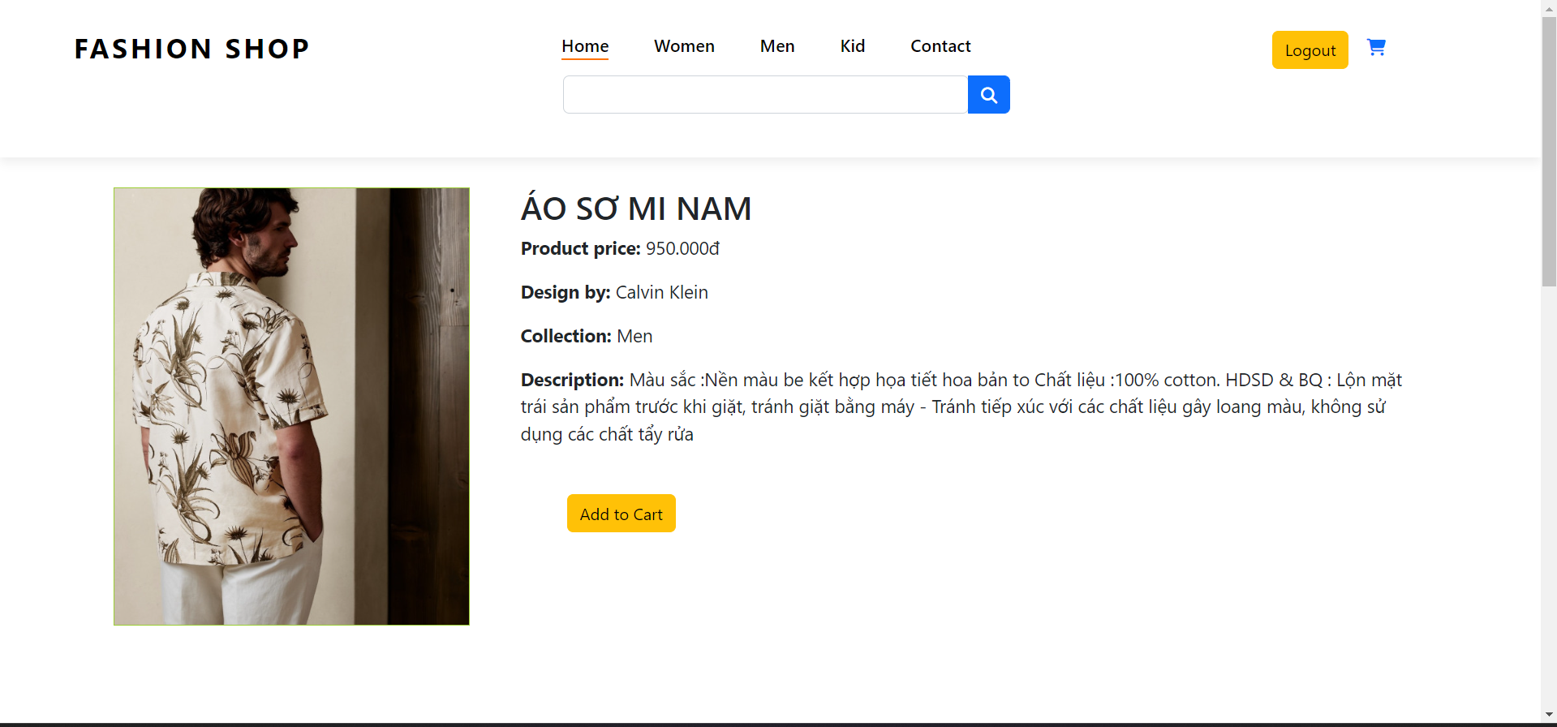 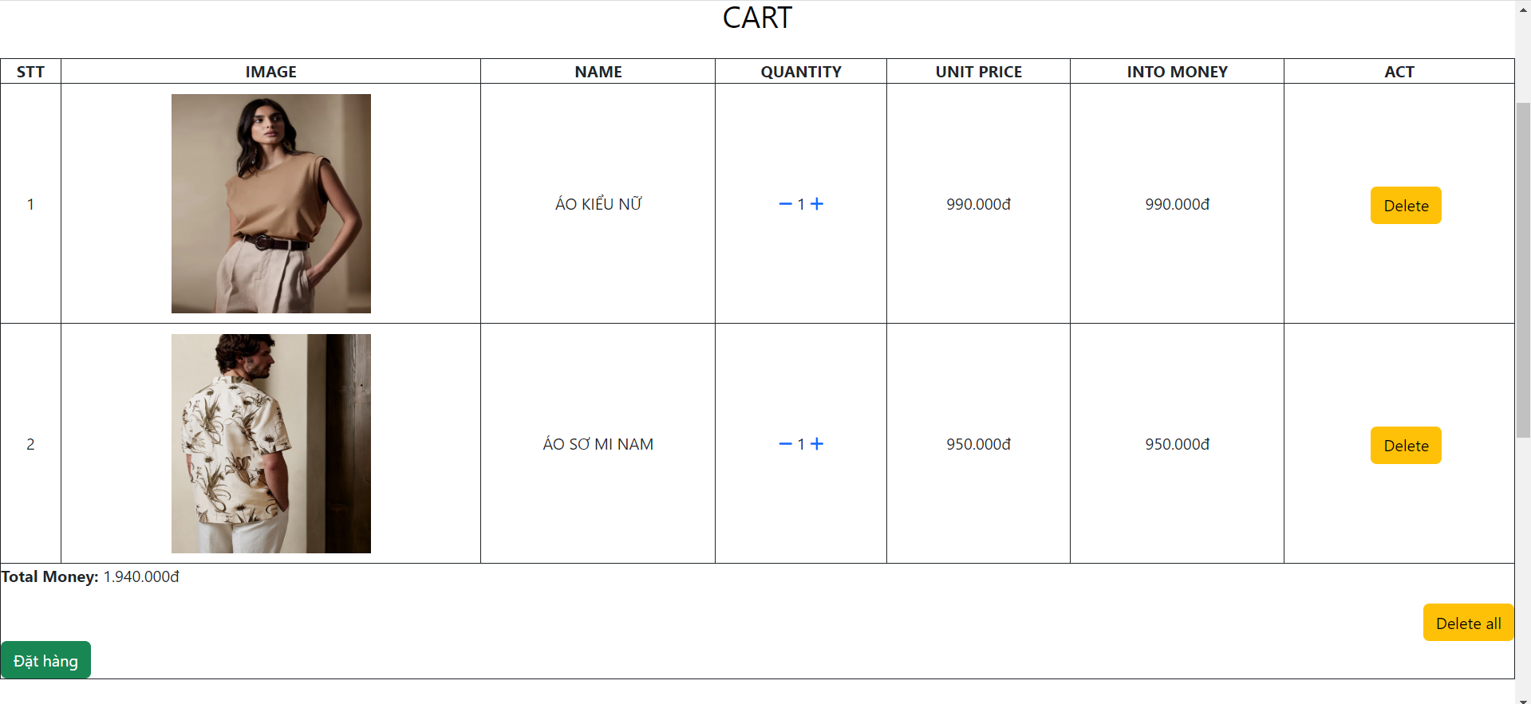

* Kid.

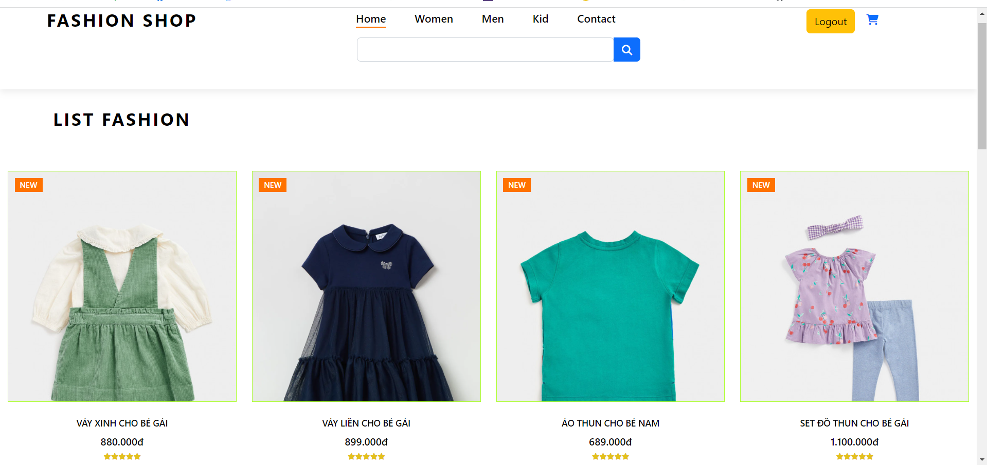

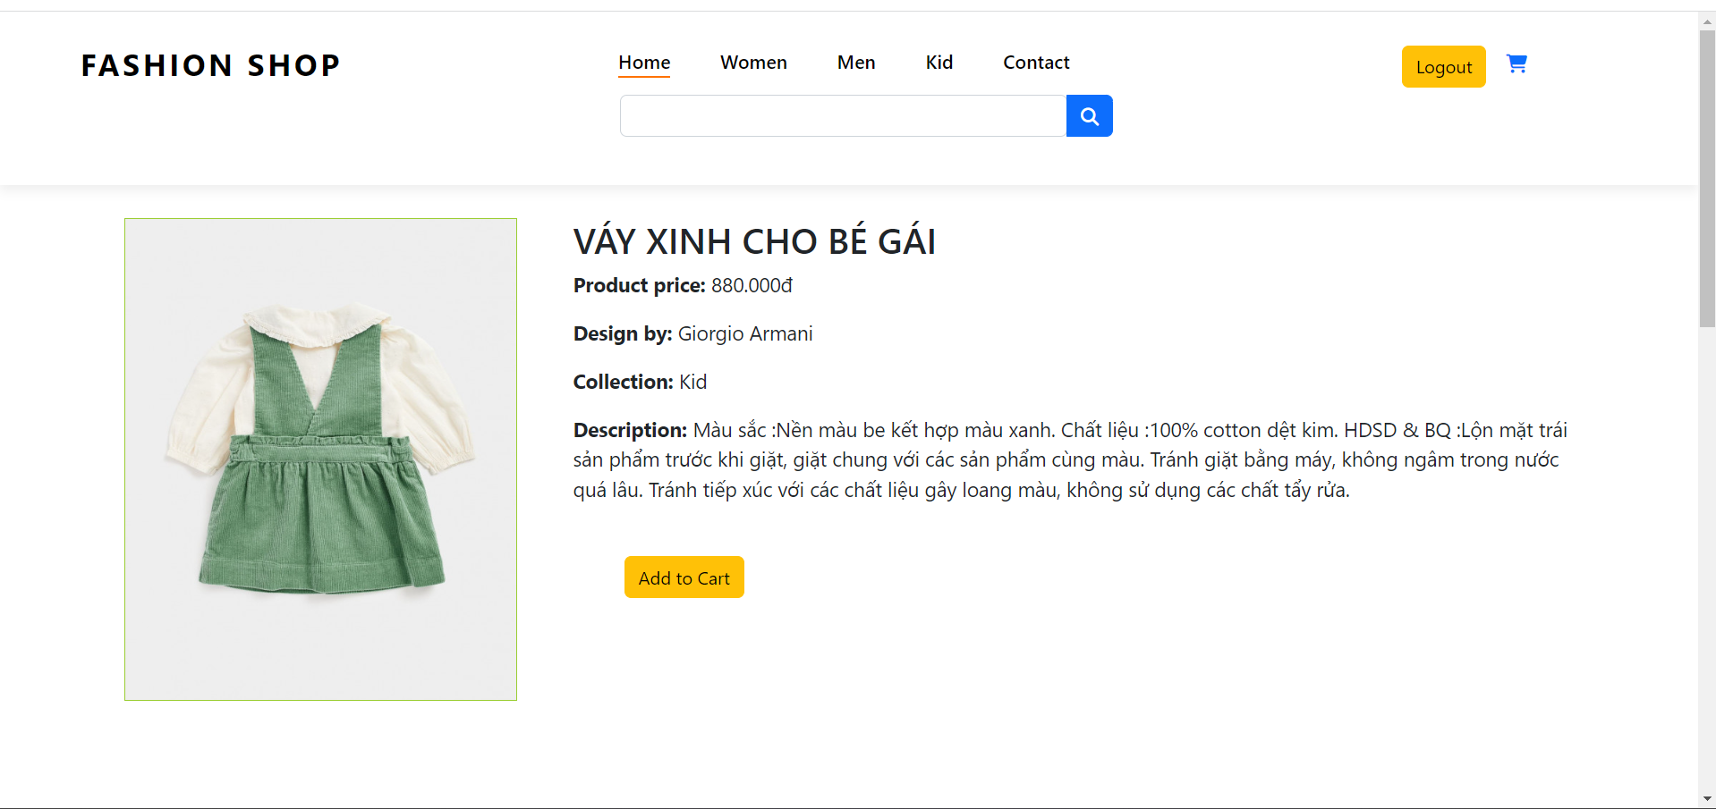 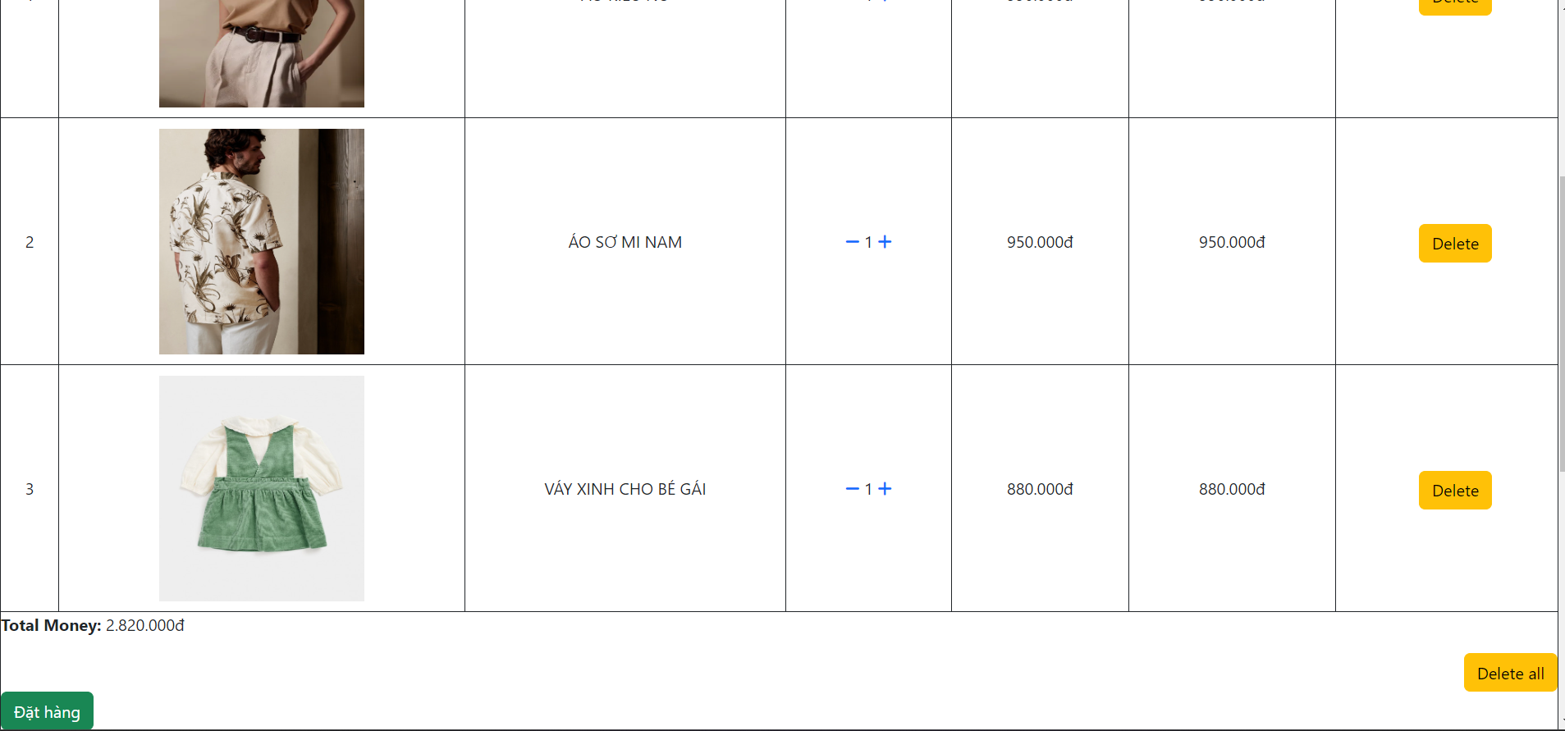

* Contact.

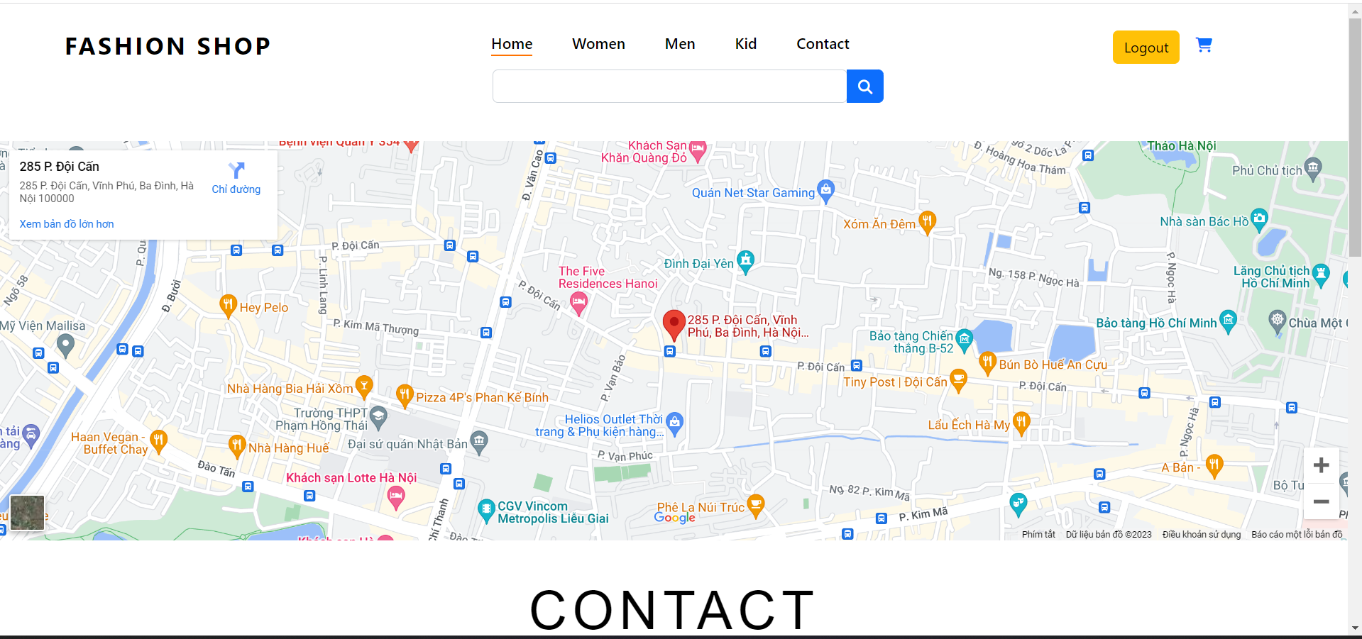 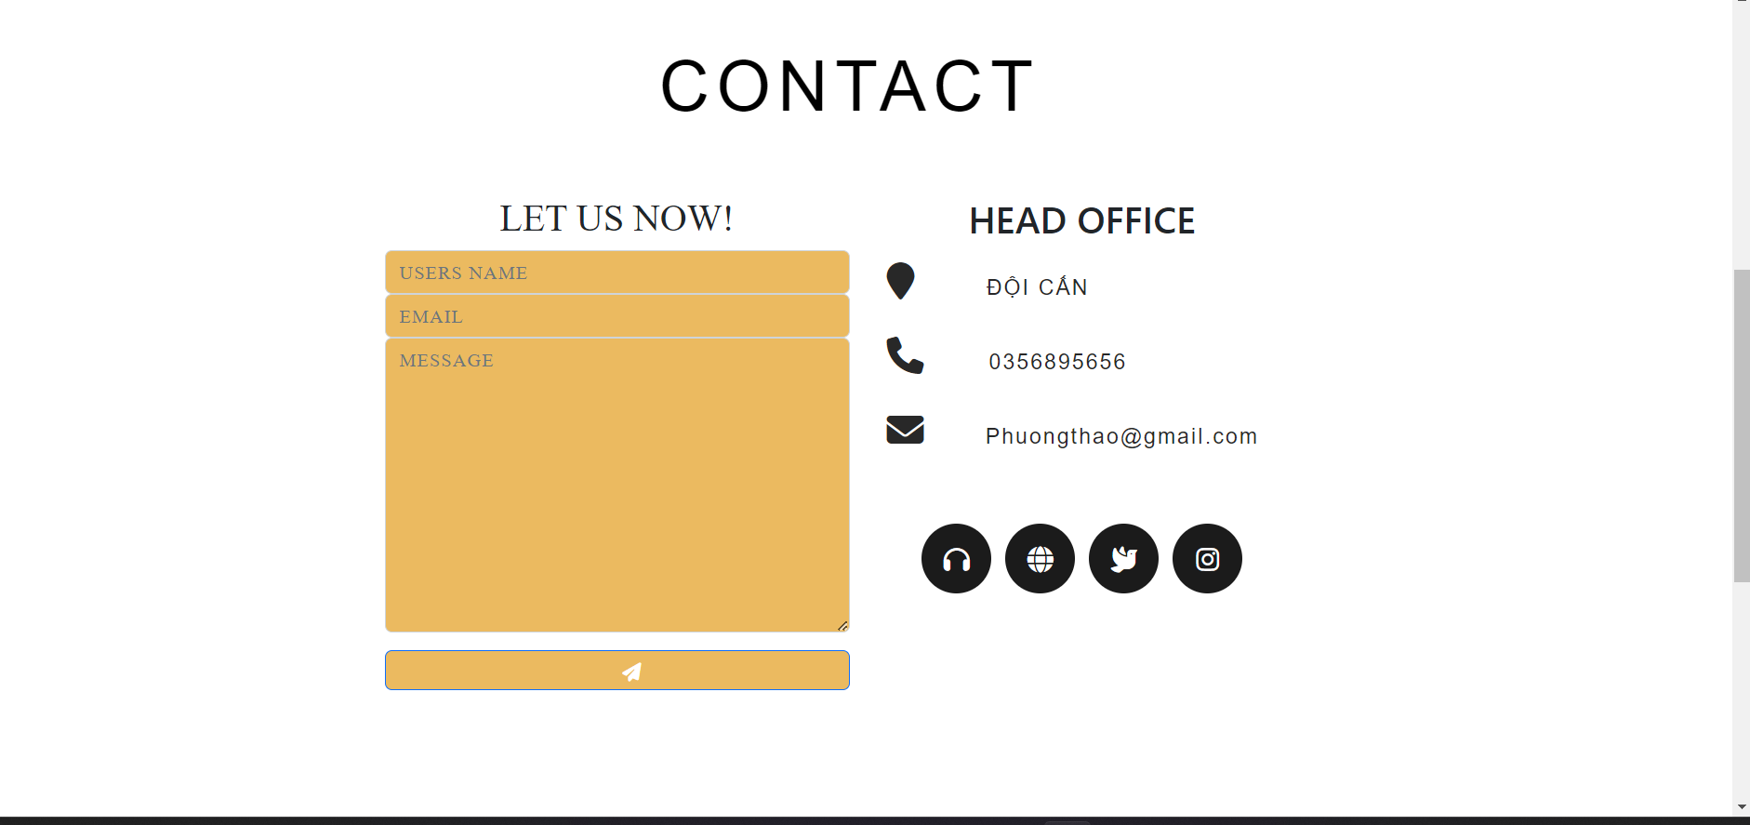 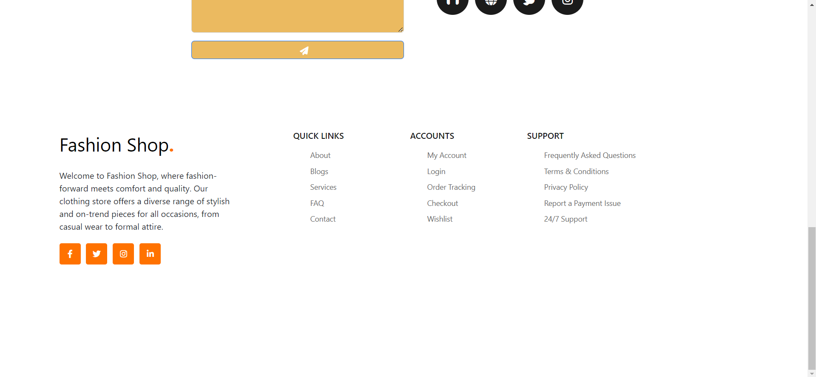

* About us.

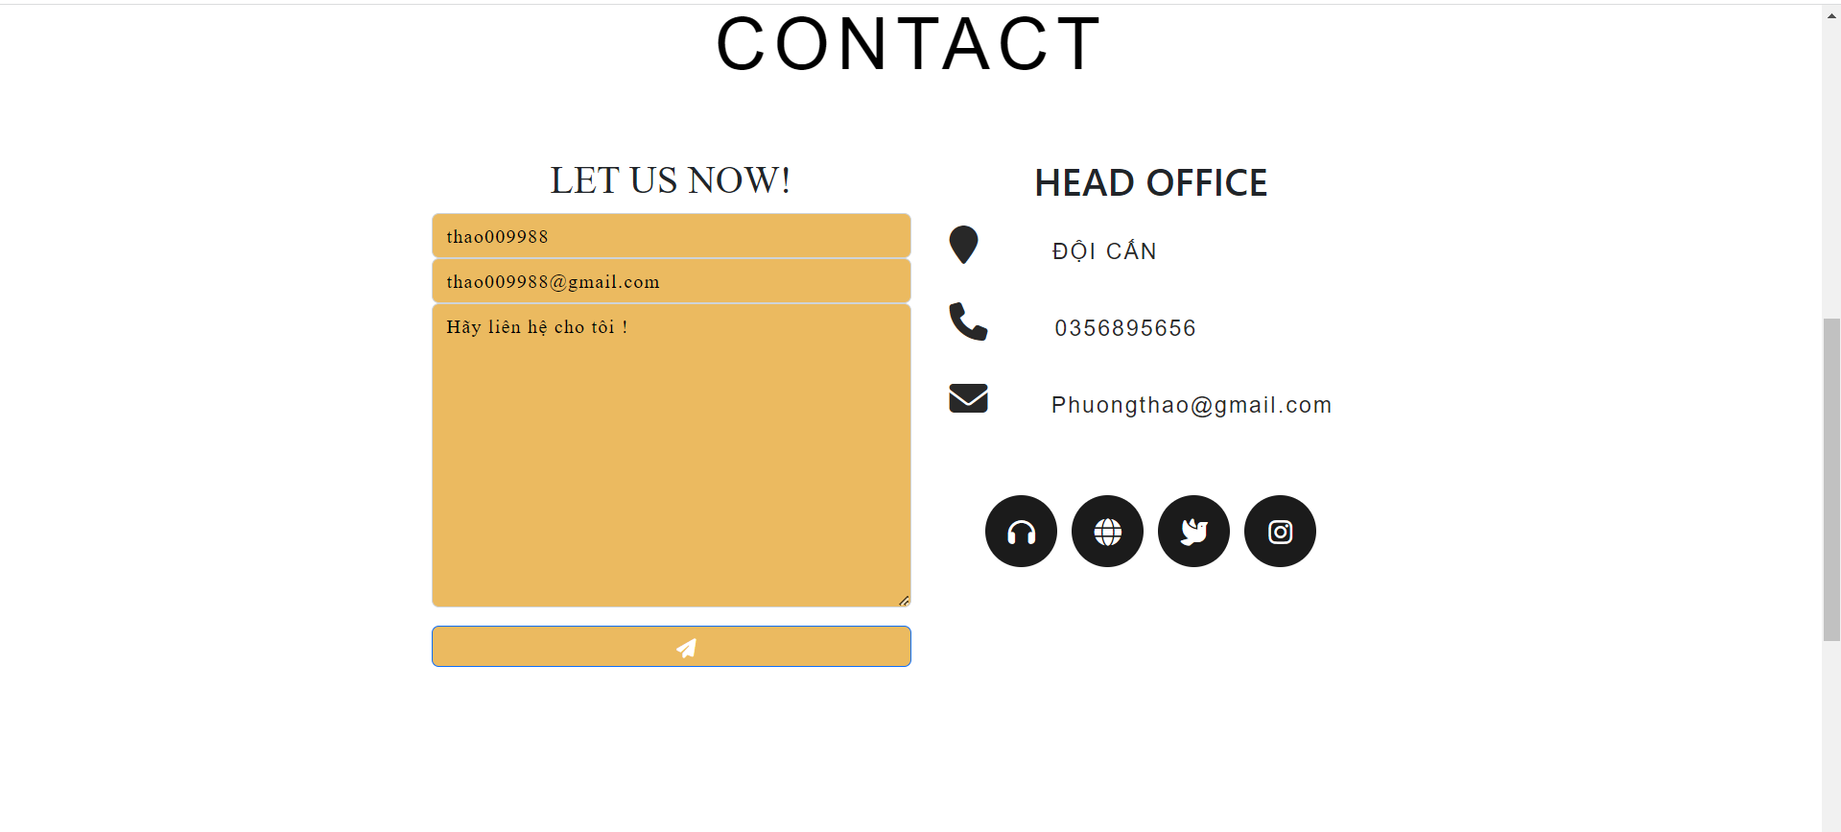

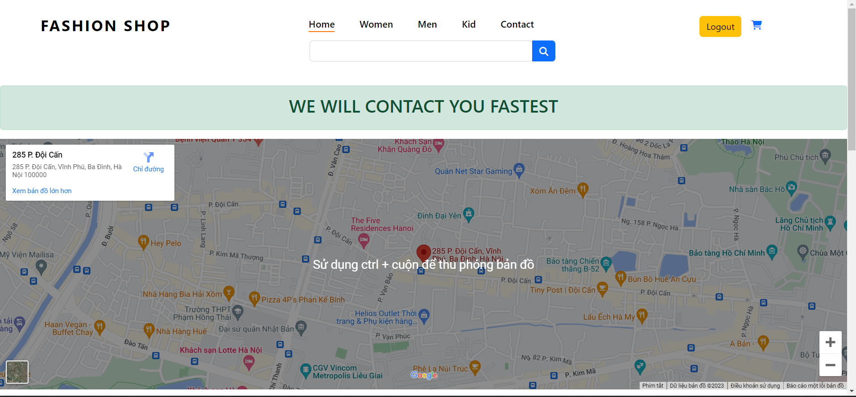

# Task sheet

| **Task** | **Start time** | **Finish time** | **Implemented by** | **Evaluation(%)** |
| --- | --- | --- | --- | --- |
| **Feasibility study phase** |  |  |  |  |
| Read, understand and analyze the topic. | 18-04-23 | 20-04-23 | KHANH NGO DUONG | 5% |
| THAO NGUYEN PHUONG |
| TRANG KHUAT THI THUY |
| NGHIA NGUYEN DINH |
| Build database | 20-04-23 | 21-04-23 | KHANH NGO DUONG | 60% |
|
| Contribute ideas to edit the database | 22-04-23 | 25-04-23 | THAO NGUYEN PHUONG | 15% |
| NGHIA NGUYEN DINH |
| TRANG KHUAT THI THUY |
| Receive comments to edit the database | 25-04-23 | 26-04-23 | THAO NGUYEN PHUONG | 15% |
| KHANH NGO DUONG |
|  |
| Complete database | 26-04-23 | 27-04-23 | KHANH NGO DUONG | 5% |
| **Requirement Analysis phase** |  |  |  |  |
| Analyze admin page | 27-04-23 | 30-04-23 | KHANH NGO DUONG | 50% |
| THAO NGUYEN PHUONG |
|  |
|  |
| Analysis of the homepage interface | 30-04-23 | 02-05-23 | KHANH NGO DUONG | 50% |
| THAO NGUYEN PHUONG |
| NGHIA NGUYEN DINH |
| TRANG KHUAT THI THUY |
| **Design phase** |  |  |  |  |
| Design the main interface | 02-05-23 | 06-05-23 | TRANG KHUAT THI THUY | 70% |
| NGHIA NGUYEN DINH |
| Contribute ideas to edit the interface | 06-05-23 | 07-05-23 | KHANH NGO DUONG | 25% |
| THAO NGUYEN PHUONG |
| Synthesize comments to complete the interface design | 07-05-23 | 09-05-23 | KHANH NGO DUONG | 5% |
| **Development phase** |  |  |  |  |
| Design functions for registration, login, collection display, fashion designer display, shopping cart, checkout, contact | 09-05-23 | 13-05-23 | KHANH NGO DUONG  THAO NGUYEN PHUONG | 50% |
| Design login, create account, display, add, edit, delete products, collections, designers, products in cart.... | 09-05-23 | 13-05-23 | KHANH NGO DUONG  THAO NGUYEN PHUONG | 50% |
| **Testing phase** |  |  |  |  |
| User page: -          Check login, register -          Check button, link -          Check the article function -          Check the news function  -          Check the cart function  -          Check the payment function | 13-05-23 | 14-05-23 |  | 50% |
| KHANH NGO DUONG |
|  |
| NGHIA NGUYEN DINH |
| THAO NGUYEN PHUONG |
| Admin page : | 13-05-23 | 14-05-23 | KHANH NGO DUONG | 50% |
| - Check display, add, edit, delete products, collections, fashion designers, orders, order details, customer contact information... | THAO NGUYEN PHUONG |
| - Check account creation |  |
| Prepare documents | 14-05-23 | 16-05-23 | TRANG KHUAT THI THUY  THAO NGUYEN PHUONG  KHANH NGO DUONG  NGHIA NGUYEN DINH |  |
| **Deployment phase** |  |  |  |  |
| submit source code and database | 17-05-23 | 17-05-23 | THAO NGUYEN PHUONG |  |